Case study for

*Murach’s ASP.NET Core MVC*

The case study described in this document is a series of assignments that let you apply the programming skills you learn in *Murach’s ASP.NET Core MVC* by developing a website called SportsPro Technical Support. This website is designed for the technical support department of a hypothetical software company that develops software for sports leagues. The purpose of the website is to track technical support service calls (referred to as *incidents*) in a database that also stores information about the company’s customers, software products, and technicians.

An introduction to the case study 2

The website 2

The database 2

A starting point 3

The assignments 3

Assignment 3-1: Set up the Home page 4

Assignment 4-1: Manage products 5

Assignment 4-2: Manage technicians 7

Assignment 4-3: Manage customers 9

Assignment 4-4: Manage incidents 11

Assignment 6-1: Improve the URLs for the app 13

Assignment 7-1: Improve the Razor views 14

Assignment 8-1: Use TempData to display messages 15

Assignment 8-2: Use a view model with the Incidents Manager 15

Assignment 9-1: Update incidents 16

Assignment 10-1: Add filtering to a page 18

Assignment 11-1: Improve validation 19

Assignment 12-1: Manage registrations 21

Assignment 12-2: Encapsulate the data layer 23

Assignment 14-1: Automate testing 24

Assignment 15-1: Use tag helpers, partial views, and view components 25

Assignment 16-1: Authenticate and authorize users 26

# An introduction to the case study

This introduction describes the SportsPro Technical Support website and the database that it uses. In addition, it describes a starting point that your instructor may provide as well as some guidelines for completing each assignment.

### The website

The SportsPro Technical Support website consists of web pages that support two types of users. First, it lets administrators manage the products, technicians, customers, incidents, and product registrations that are in the database. Second, it lets technicians update incidents that have been assigned to them.

Most assignments have you add one or more new pages to the SportsPro app or improve pages that you added in an earlier assignment. For example, assignment 4-1 has you add pages that let an administrator manage products. If you complete all of the assignments for this book, you will create a relatively realistic web app.

Note that the first number in an assignment refers to the chapter in the book. So, for example, you can complete assignments 4-1 through 4-4 after reading chapter 4. Similarly, you can complete assignment 7-1 after reading chapter 7.

### The database

The database for the SportsPro website stores the data that’s needed to track technical support incidents. For the completed website, the database should include tables for storing data about the company’s products, technicians, customers, incidents, and registrations. If your instructor provides you with a starting point for the case study, you can use that starting point to create the database and populate it with some data. Otherwise, you can use EF Code First development to create or update each table as you complete each assignment. To do that, you may need to refer to the beginning of chapter 12 to master all the skills you need for using EF Code First development to configure and create a database.

The Incidents table contains one row for each technical support incident. Each row in the Incidents table is related to one row in the Customers table, which contains data about the company’s customers; one row in the Products table, which contains data about the company’s products; and one row in the Technicians table, which contains data about the company’s technical support staff. In addition, each row in the Customers table is related to one row in the Countries table, which stores a list of available countries.

The Registrations table, on the other hand, is a linking table that creates a many-to-many relationship between the Customers and Products tables. As a result, each row relates one customer to one product. This allows one customer to register many products, and it allows one product to be registered by many customers.

## A starting point

To make it easy to get started, your instructor may provide a version of the SportsPro app that includes some files that will help you get started. These files include the DB context and entity classes that you can use to create the database for the website and fill it with some starting data. If you run the SportsPro app provided by your instructor, it should display a page like the one shown in assignment 3-1.

Most of the assignments within this case study correspond to one of the links on the page shown in assignment 3-1. However, if you click on any of these links, they display an error message that indicates that the page can’t be found. That’s because you still need to implement these assignments.

If your instructor doesn’t provide a version of the SportsPro app to you, you can complete assignment 3-1 to get your website started. Then, in later assignments, you can use EF Code First development to create the tables in the database.

# The assignments

The description of each assignment usually includes one or more screen captures that show how the pages should appear when they’re completed as well as specifications for how the assignment should be coded. This information is detailed enough for you to complete each assignment. However, you’ll need to use your best judgment on how to code many of the details. To do that, write the code in the way that you think is best, based on the skills that were presented in the book and the guidelines provided to you by your instructor.

Unless you’re instructed otherwise, you can implement each assignment using any programming techniques you wish. In some cases, however, the assignment’s specifications will direct you to use a specific programming technique. For example, an assignment may direct you to use sessions. In that case, you should implement the assignment as directed.

Assignment 3-1: Set up the Home page

For this assignment, you’ll create the Home page for the app. This Home page includes a navigation bar and some menu options for later assignments.

The Home page

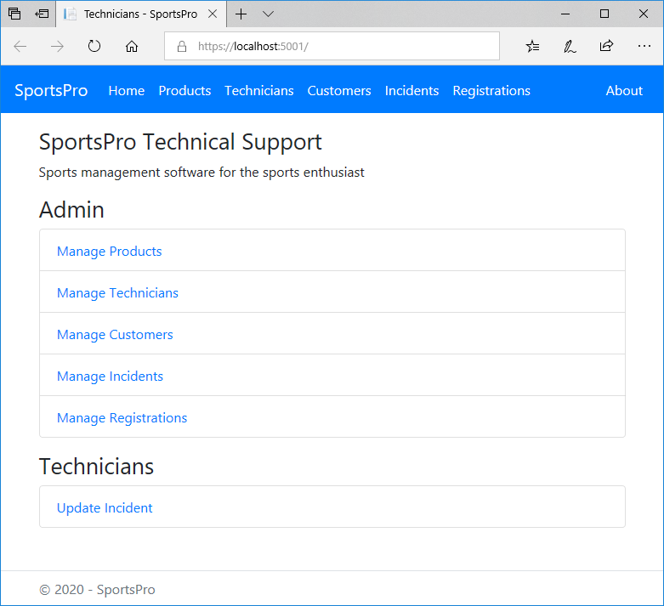

Specifications

* Create an app and that’s based on the Model-View-Controller template. Then, edit the code that’s provided by that template to create a Home page like the one shown above.
* Use a Razor layout to store elements that are common to all pages, such as the navigation bar and the footer.
* Use Bootstrap classes to format the HTML elements and to create the navigation bar.
* Mark all navigation bar items as active.

Assignment 4-1: Manage products

For this assignment, you’ll modify the app so it lets an admin user view, edit, and delete existing products as well as add new products.

The Product Manager page

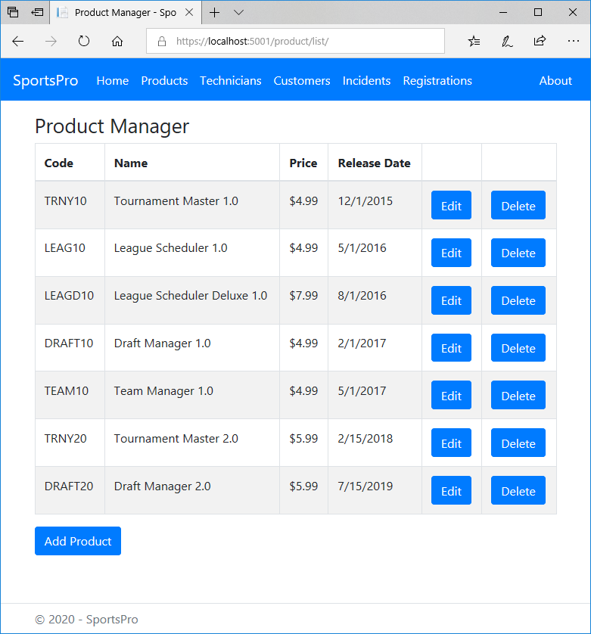

Specifications

* When the user clicks the Manage Products link on the Home page or the Products link in the navbar, the app should display the Product Manager page.
* When the user clicks the Add Product button, the app should display the Add/Edit Product page with blank Code and Name fields but with the current date in the Release Date field.
* When the user clicks the Edit button for a product, the app displays the Add/Edit Product page with the current data for the product.
* When the user clicks the Delete button for a product, the app should display a Delete Product page that confirms the deletion.

The Add/Edit Product page

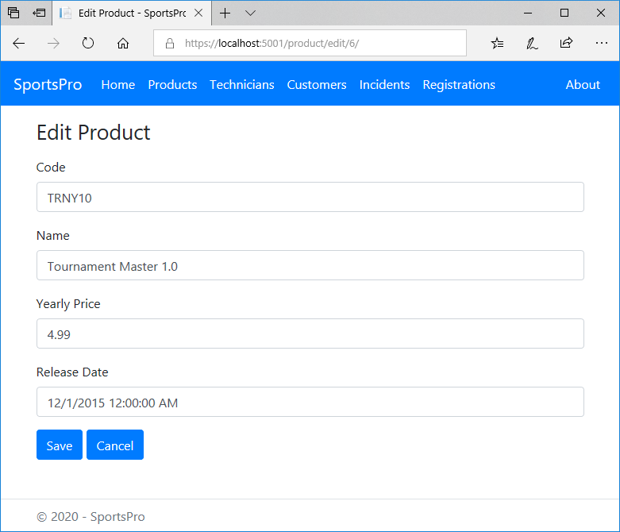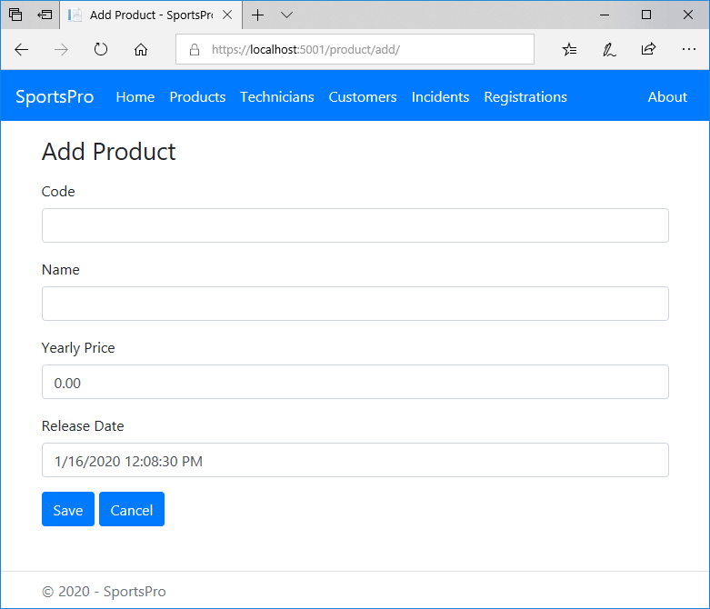

Specifications (continued)

* The app should display the Product Manager page when the user completes or cancels an add, edit, or delete operation.
* Validate the data the user enters in the Add/Edit Product page to be sure that the user enters a product code, name, and price. If this data isn’t provided, the app should display a summary of the validation errors above the form.
* Use lowercase URLs with a trailing slash.
* Use the same Razor view file to add and edit a product.
* If you have trouble adding migrations or updating the database, refer to the EF PowerShell commands described in chapters 4 and 12.

Assignment 4-2: Manage technicians

For this assignment, you’ll modify the app so it lets an admin user view, edit, and delete existing technicians as well as add new technicians.

The Technician Manager page

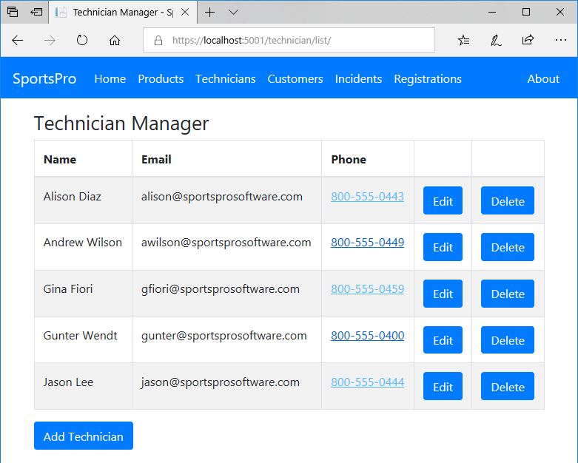

Specifications

* When the user clicks the Manage Technicians link on the Home page or the Technicians link in the navbar, the app should display the Technician Manager page.
* When the user clicks the Add Technician button, the app should display the Add/Edit Technician page with blank fields.
* When the user clicks the Edit button for a product, the app should display the Add/Edit Technician page with the current data for the technician.
* When the user clicks the Delete button for a technician, the app should display a Delete Technician page that confirms the deletion.

The Add/Edit Technician page

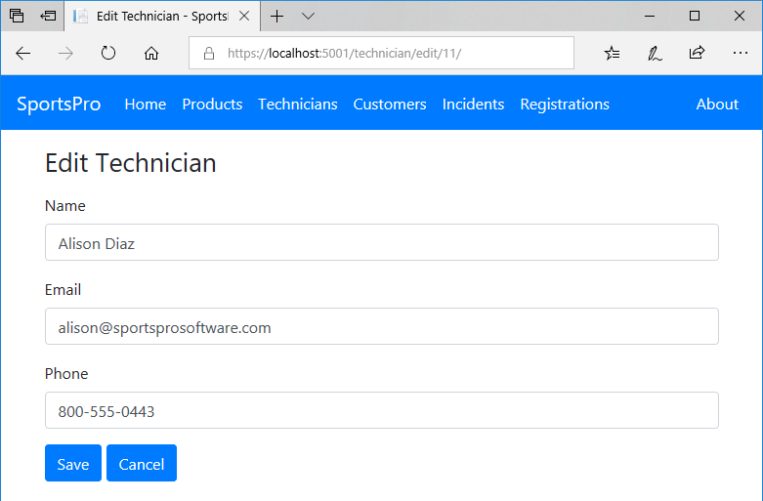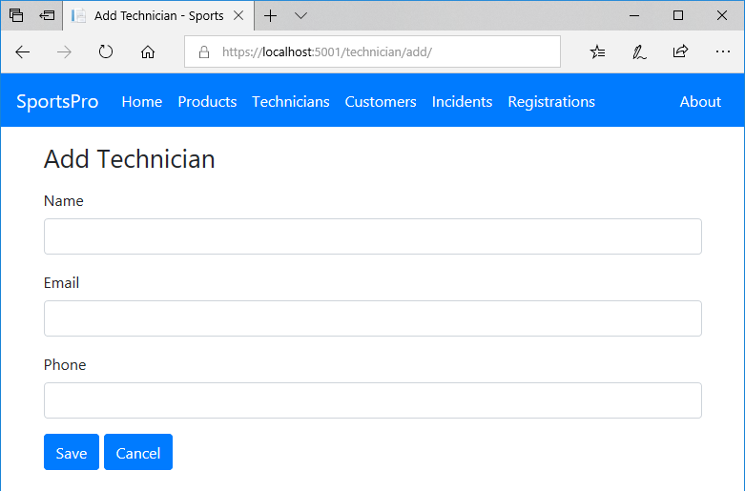

Specifications (continued)

* The app should display the Technician Manager page when the user completes or cancels an operation that adds, edits, or deletes a technician.
* Validate the data the user enters in the Add/Edit Technician page to be sure that the user enters values for all fields. If this data isn’t provided, the app should display a summary of the validation errors above the form.
* Use lowercase URLs with a trailing slash.
* Use the same Razor view file to add and edit a technician.

Assignment 4-3: Manage customers

For this assignment, you’ll modify the app so it lets an admin user view, edit, and delete existing customers as well as add new customers.

The Customer Manager page

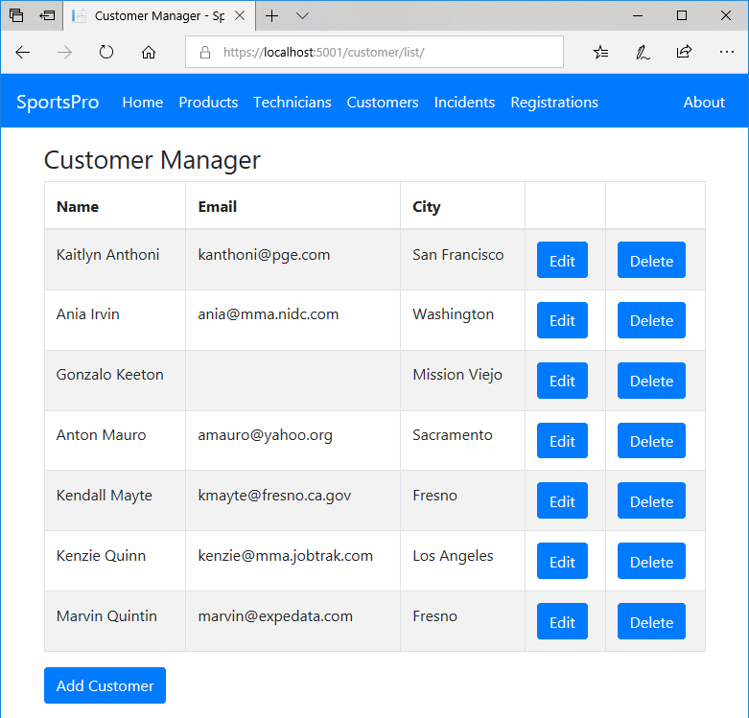

Specifications

* When the user clicks the Manage Customers link from the Home page or the Customers link from the navbar, the app should display the Customer Manager page.
* When the user clicks the Add Customer button, the app should display the Add/Edit Customer page with blank fields.
* When the user clicks the Edit button for a customer, the app displays the Add/Edit Customer page with the data for the selected customer.
* When the user clicks the Delete button for a customer, the app should display a Delete Customer page that confirms the deletion.

The Add/Edit Customer page

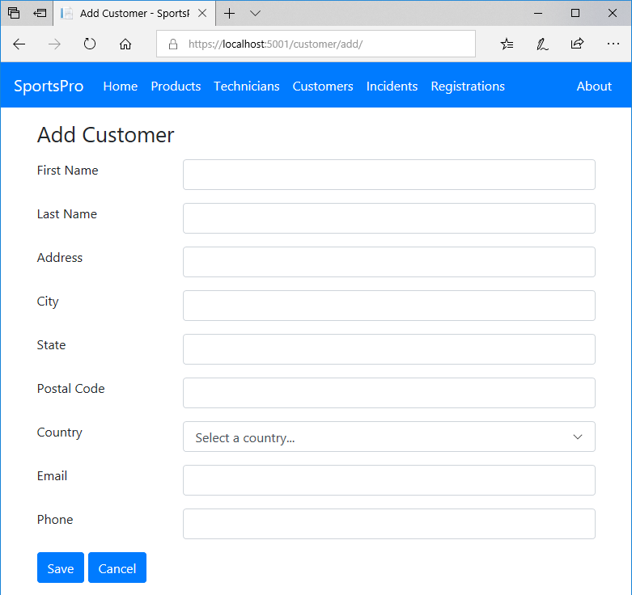

Specifications (continued)

* The app should display the Customer Manager page when the user completes or cancels an operation for adding, editing, or deleting a customer.
* Validate the data the user enters in the Add/Edit Customer page. To be valid…
* The user must select a country from the drop-down list of countries.
* The Email and Phone fields are optional.
* All other fields are required.
* Use the same Razor view file to add and edit a customer.
* In the Country drop-down list, display all countries that are available from the database. If necessary, add some countries to the database.
* When the app displays the Edit Customer page, make sure to select the correct country for the specified customer.

Assignment 4-4: Manage incidents

For this assignment, you’ll modify the app so it lets an admin user view, edit, and delete existing incidents as well as add new incidents.

The Incident Manager page

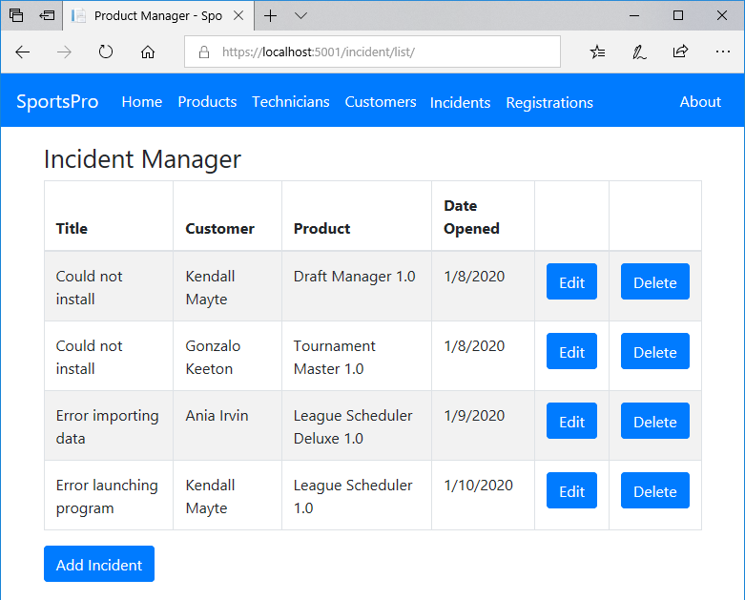

Specifications (continued)

* When the user clicks the Manage Incidents link from the Home page or the Incidents link from the navbar, the app should display the Incident Manager page.
* When the user clicks the Add Incident button, the app should display the Add/Edit Incident page with blank fields.
* When the user clicks the Edit button for an incident, the app should display the Add/Edit Incident page with the data for the selected incident.
* When the user clicks the Delete button for an incident, the app should display a Delete Incident page that confirms the deletion.

The Add/Edit Incident page

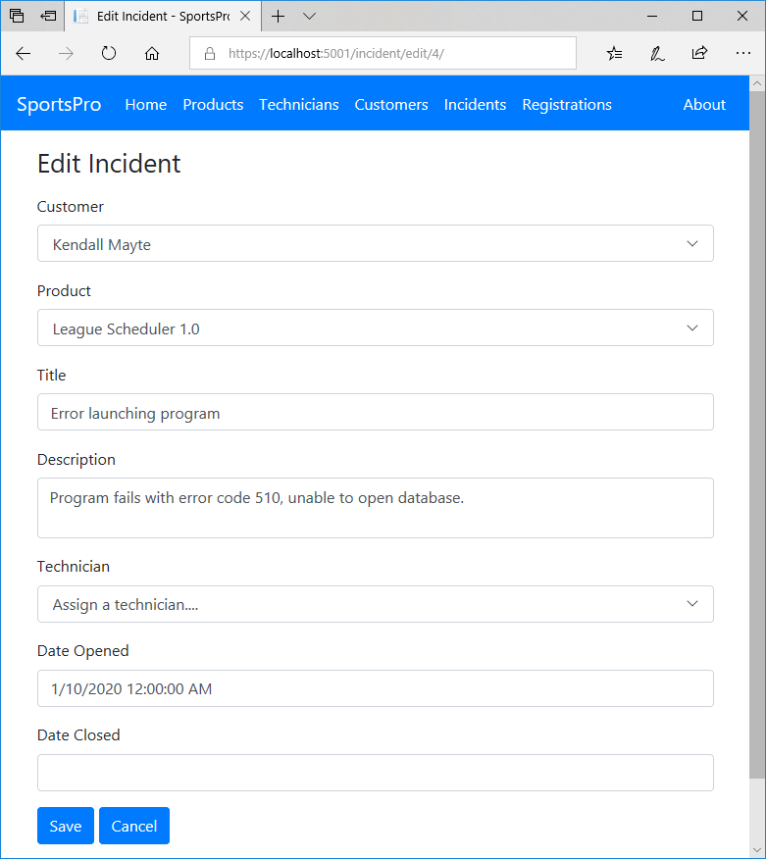

Specifications (continued)

* The app should display the Incident Manager page when the user completes or cancels an operation for adding, editing, or deleting an incident.
* Validate the data the user enters in the Add/Edit Customer page. To be valid…
* The user must select a customer and a product from the drop-down lists.
* The Technician and Data Opened fields are optional.
* All other fields are required.
* Use the same Razor view file to add and edit a customer.
* To make the Technician field optional, make sure to specify a nullable int type (?int) for the TechnicianID property of the Incident entity class.

Assignment 6-1: Improve the URLs for the app

For this assignment, you’ll modify the SportsPro website so it uses some skills described in chapter 6.

The About page

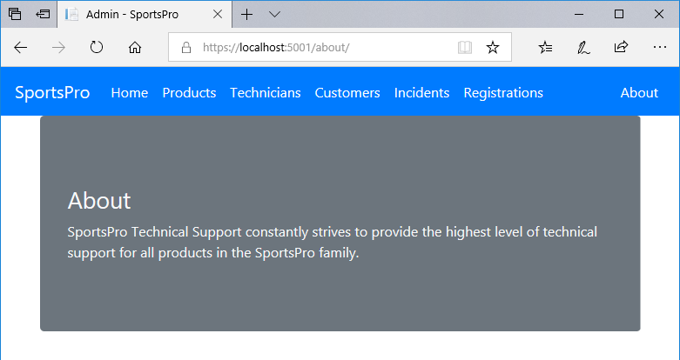

Specifications

* Add an About page like the one shown above that’s displayed by the About action of the Home controller.
* Use attribute routing to shorten some of the URLs for the app like this:

Request URL Controller/Action

**/about Home/About**

**/products Product/List**

**/technicians Technician/List**

**/customers Customer/List**

**/incidents Incident/List**

Assignment 7-1: Improve the Razor views

For this assignment, you’ll modify the SportsPro website so it uses some skills described in chapter 7.

The navigation bar when the Product Manager page is displayed

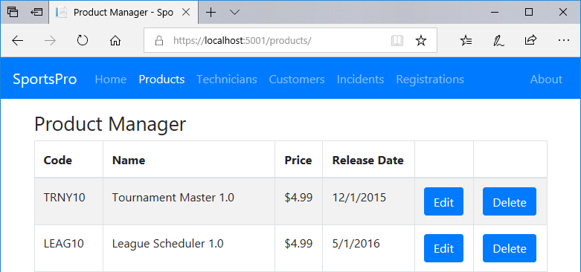

The navigation bar when the Technician Manager page is displayed

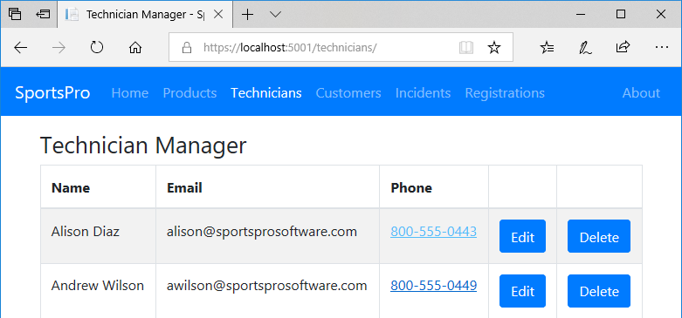

Specifications

* Get the navigation links to work correctly. For example, the Products link should be active for the Product controller, the Technicians link should be active for the Technicians controller, and so on.
* Convert the Razor foreach loops that display the items for the <select> elements so they use the asp-items tag helper instead. To include an extra item as the first item in the drop-down list, you can still include an <option> element like this one:

<option value="">Select a product...</option>

* Remove the jQuery libraries for validation from the layout for the app and only include them in views where they’re necessary such as the views for the Add/Edit pages.

Assignment 8-1: Use TempData to display messages

For this assignment, you’ll modify the SportsPro website so it uses TempData to display messages when an operation is successful.

The Product Manager page after a new product has been added

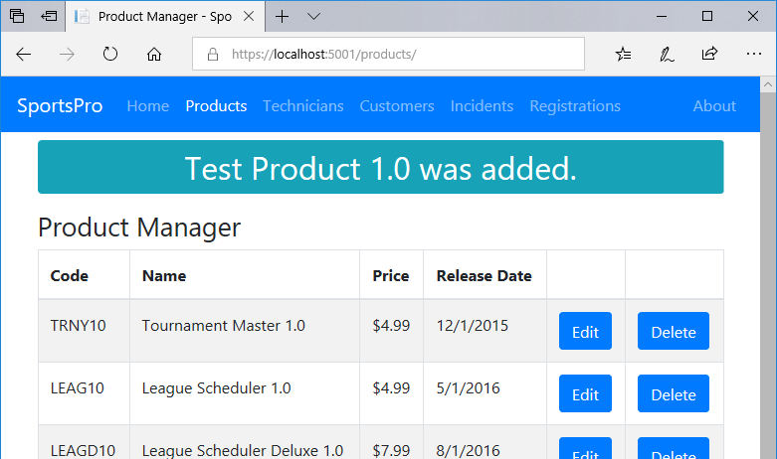

Specifications

* In the Product controller, edit the return types of the action methods so an action method that returns a view specifies ViewResult as the return type and an action method that redirects specifies RedirectToActionResult as the return type.
* In the Product controller, use TempData to store a success message after each successful add, edit, or delete operation. Then, display the message on the Product Manager page. To do that, you can add some code to the layout that displays a TempData message across the top of the page if the message exists.

Assignment 8-2: Use a view model with the Incidents Manager

For this assignment, you’ll modify the SportsPro website so it uses a view model to pass data to the List Manager page and its Add/Edit Incident page.

Specifications

* Use a view model to pass data to the Incident Manager page. This view model should store a list of incidents and a string that specifies the filtering for the page.
* Use a view model to pass data to the Add/Edit Incident page. This view model should store a list of customers, a list of products, a list of technicians, the current incident, and a string that specifies whether the page is for an Add or Edit operation.

Assignment 9-1: Update incidents

For this assignment, you’ll add some pages that let technicians view all of their assigned and open incidents. Then, the technician can edit an incident’s description and specify a close date for the incident.

The Get Technician page

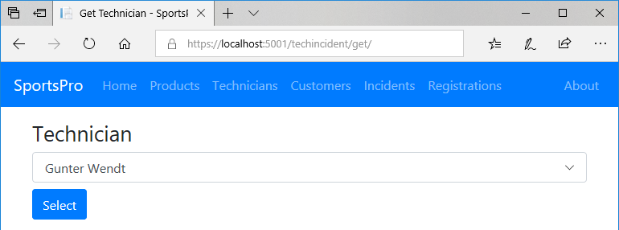

The Incidents by Technician page

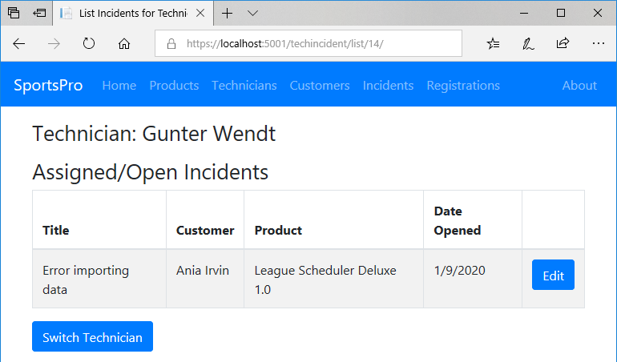

Specifications

* The Get Technician page is only displayed by the Update Incident link on the Home page for the website. There’s no link for it in the navigation bar.
* The Get Technician page allows the user to select the technician name. If the user doesn’t select a name, the app should display a message indicating that the user must select a technician.
* The Incidents by Technician page displays all open incidents that have been assigned to the selected technician. Or, if there are no open incidents for the current technician, this page displays a message that indicates that there are no open incidents.
* To switch technicians, the user can click on the Switch button. This displays the Get Technician page again.

The Edit Incident page

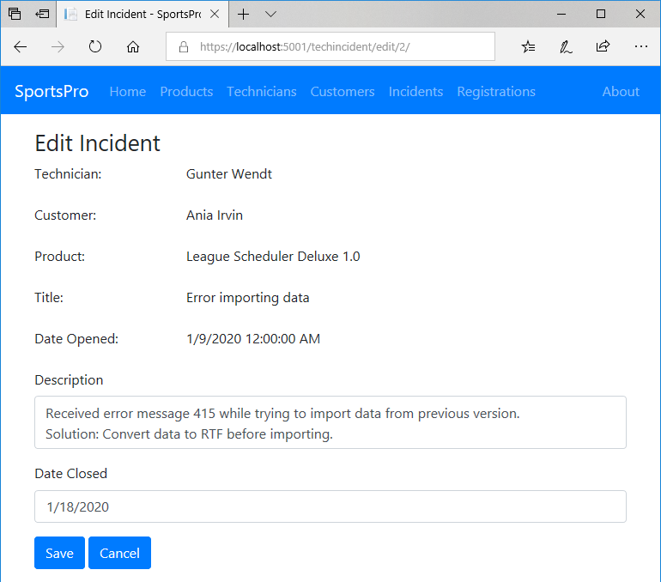

Specifications (continued)

* From the Incidents by Technician page, the user can click the Edit button for an incident to update that incident. This displays the Edit Incident page.
* Then Edit Incident page allows the technician to modify the description and optionally enter the date the incident was closed and click on the Save button.
* If the technician successfully updates an incident or cancels the update operation, the app should display the Incidents by Technician list again.
* The website should store the technician’s ID in session state. That way, the website can “remember” the current technician.

Assignment 10-1: Add filtering to a page

For this assignment, you’ll modify the SportsPro website so it allows an admin user to filter the incidents to view all incidents, unassigned incidents, or open incidents.

The Incident Manager page with filtering

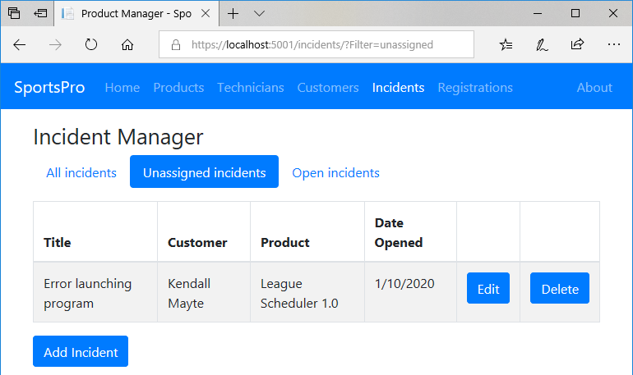

Specifications

* The Incident Manager page should include three links styled as Bootstrap pills that allow the user to filter the incidents by only displaying unassigned incidents (TechnicianID is null) or only displaying open incidents (DateClosed is null).

Assignment 11-1: Improve validation

For this assignment, you’ll modify the SportsPro website so it improves the data validation for the Add/Edit Customer page.

The Edit Customer page

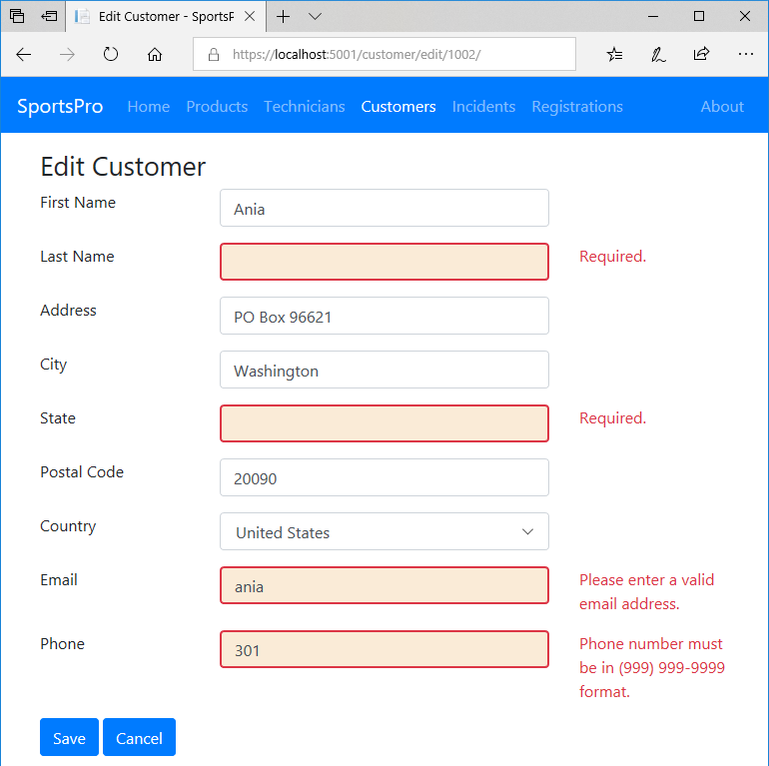

Specifications

* Same as assignment 4-3 but with improved data validation for some fields on the Add/Edit Customer page.
* Here are the data validation requirements...
* The first name, last name, address, city, state, and email are required and must have at least 1 and less than 51 characters.
* The postal code is required and must have at least 1 and less than 21 characters.
* The phone number is not required, but if the user enters one, it must be in the “(999) 999-9999” format. (You can search the Internet for an appropriate regular expression.)
* The email address must be a valid email address. To do that, you can use the DataType validation attribute:

[DataType(DataType.EmailAddress)]

The Add Customer page

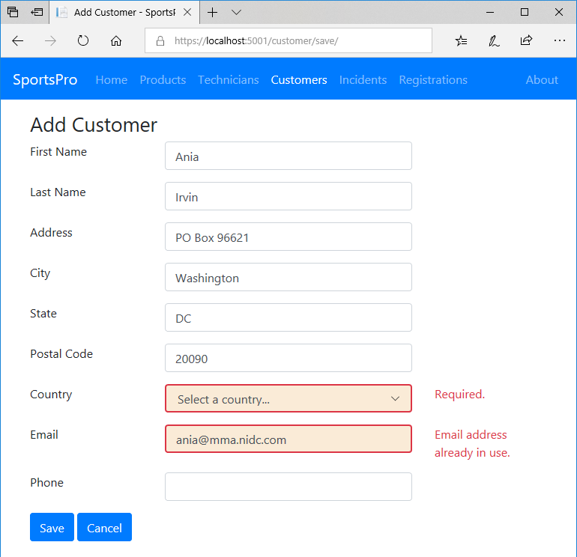

Specifications (continued)

* More data validation requirements...
* The drop-down list must be set to a valid country (not the “Select a country” item).
* When adding a new customer, the email address must not already be used by another customer.
* Add custom CSS that uses a different border and background for the <input> elements that contain invalid data.

Assignment 12-1: Manage registrations

For this assignment, you’ll add some pages that let an admin user view the product registrations for a customer and add new product registrations as well.

The Get Customer page

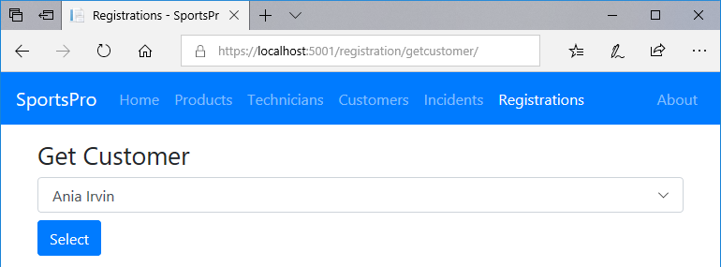

Specifications

* The Get Customer page is displayed by the Manage Registrations link on the Home page and by the Registrations link in the navigation bar.
* The Get Customer page allows the user to select the customer. If the user doesn’t select a customer, the app should display a message indicating that the user must select a customer.

The Registrations page

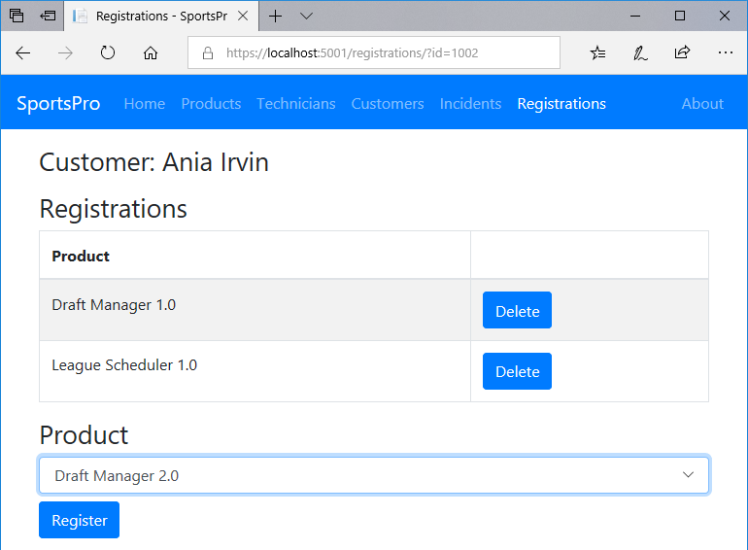

Specifications (continued)

* The Registrations page displays the name of the selected customer and all products that have been registered for that customer. Or, if there are no products registered for the selected customer, this page indicates that there are no products registered for the selected user.
* To register a product, the user can select a product from the Product drop-down list and click the Register button. This should add the product to the table of registered products for the selected customer.
* The website should store the customer’s ID in session state. That way, the website can “remember” the current customer.
* To get these pages to work correctly, you should add a linking entity class named Registration that provides a many-to-many relationship between the Customer and Product entities.

Assignment 12-2: Encapsulate the data layer

For this assignment, you’ll modify the SportsPro website so it uses the repository pattern and the unit of work pattern to encapsulate the data layer.

Specifications

* All the code in the data layer should be stored it in its own folder (not in the Models, Views, or Controllers folder).
* The code that adds seed data should be moved out of the DB context class and into separate classes (one for each table).
* The code that configures the many-to-many relationship with the Registrations table as the linking table should be moved out of the DB context class and into a separate class.
* The data layer should use the IRepository<T> interface and the Repository<T> and QueryOptions<T> classes to implement the repository pattern.

NOTE: Because one of the queries in the TechIncident controller has multiple WHERE clauses, you should use the Repository<T> and QueryOptions<T> classes presented in chapter 13. That’s because these classes provide for multiple WHERE clauses, while the classes presented in chapter 12 only allow for provide for a single WHERE clause.

* The data layer should use an interface and a class to implement the unit of work pattern.
* The controllers should use the repository and unit of work classes instead of the DB context class.
* Controllers that only work with one DbSet can use a repository class. For instance, the Product controller only needs to work with Product objects, so it can use the Repository<Product> class.
* Controllers that work with multiple DbSets should use the unit of work class. For instance, the Incident controller works with Incident, Customer, Product, and Technician objects, so it should use the unit of work class.
* For the Customer controller to be able to use a repository or unit of work class, the Validation controller and the Check class must be updated, too.
* The TechIncident controller has a query with more than one WHERE clause. You can refer to the text in figure 13-4 for an example of how this query should look after it’s updated to use the WhereClauses property of the QueryOptions class.

Assignment 14-1: Automate testing

For this assignment, you will automate some of the testing for the app. In order to facilitate that, you’ll update the controllers to use dependency injection (DI).

The Test Explorer window

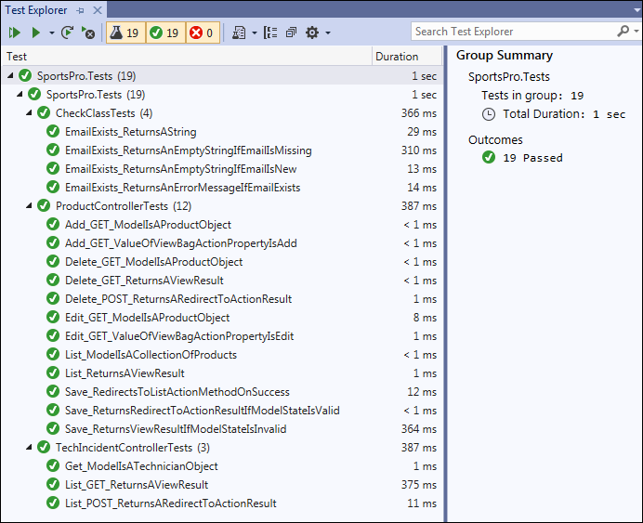

Specifications

* The controllers should receive repository or unit of work objects by dependency injection.
* The dependencies should be configured with the transient life cycle.
* To facilitate testing, the controllers should work with interfaces, not concrete objects. In addition, the return types in the unit of work interface and class should be interfaces.
* The TechIncident controller should receive an HttpContextAccessor object by DI, in addition to a unit of work object. Then, it should access data in session using the ISession object from that HttpContextAccessor object, rather than from the controller’s HttpContext property. This makes the TechIncident controller easier to test.
* The Validation controller should use action method injection.
* The solution should have a unit test project that contains tests for the controllers of the main web app. The unit test project should also contain tests for the static Check class.
* The unit test project should use Moq to create fake versions of the repository, unit of work, and HttpContextAccessor objects the controllers and/or model classes receive via DI.

Assignment 15-1: Use tag helpers, partial views, and view components

For this assignment, you will use tag helpers, partial views, and view components to reduce code duplication in your Razor views and layouts, and to simplify your controller and view model code.

Specifications

* Use a partial view to store the jQuery libraries for data validation.
* Use a tag helper to display a temporary message. The layout should no longer use Razor code to do this.
* Use a view component to display the copyright info. The layout should no longer use Razor code to do this.
* Use a tag helper to mark a current nav link as active. This should work for nav links in the navbar in the layout and for the nav pills for filtering incidents. The nav links should no longer use any Razor code to do this.
* Use view components for the options of the <select> elements for technicians, customers, countries, and products. Don’t include the <select> element itself in the partial view for a view component. That way, the <select> element can still use the asp-for attribute for model binding and data validation. Here’s an example of how a <select> element with a view component for options should look:

<select asp-for="Incident.ProductID" class="form-control">

<vc:product-drop-down-options

value="@Model.Incident.ProductID"

default-value=""

default-text="Select a product..." />

</select>

These view components should handle getting the data for the drop downs. The controllers should no longer use the ViewBag property or view model objects to pass that data to the views. If a controller previously used a unit of work object but can now use a single repository object, it should be updated to use that repository object.

* If you have a unit test project, run the tests when you make changes to the controllers to make sure those changes don’t cause your tests to fail. If you encounter errors, fix the website or unit tests as needed.

Assignment 16-1: Authenticate and authorize users

For this assignment, the admin functions will only be available to users who have logged in as an admin user.

The Login page

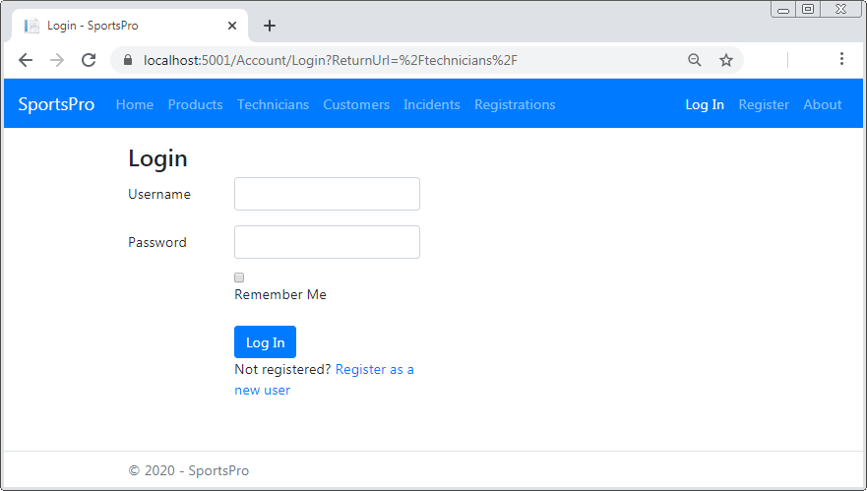

The Technician page

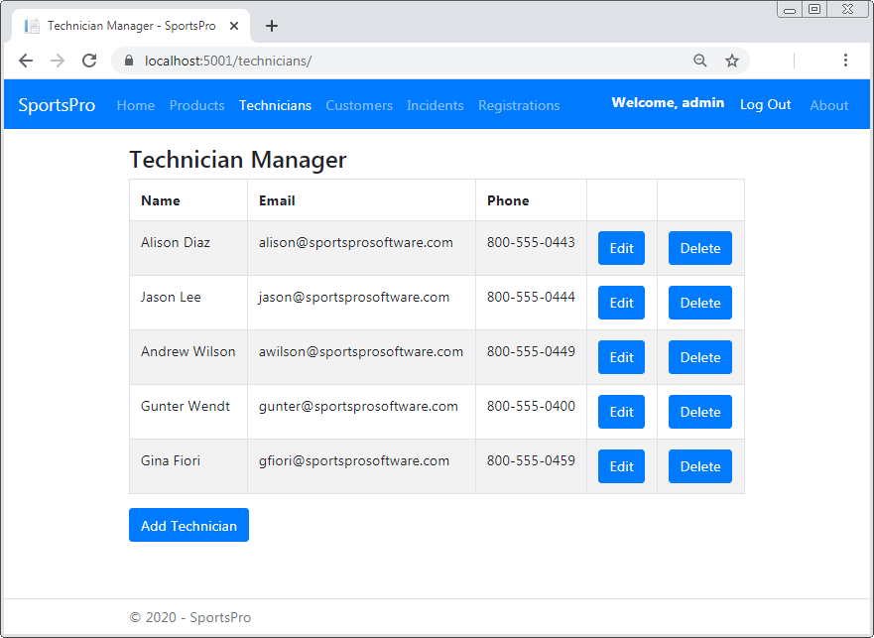

Specifications

* Anonymous users can only view the Home page, the About page, the Register page, and the Login page. If an anonymous user attempts to access any other page, the app displays the Login page.
* If the user enters a valid username and password into the Login page, the website redirects to the page the user originally clicked, if the user is authorized to view that page. Otherwise, it displays the Access Denied page.
* The navbar should display Log In and Register links to anonymous users, and a Log Out link with a welcome message to authenticated users.
* Only a user in the Admin role should be able to access the admin pages. For example, only a user that’s logged in and is in the Admin role should be able to access the Product Manager page.
* Any authenticated user should be able to access the Update Incident page that’s designed for technicians.
* On startup, the app should add a user with a username of “admin” and a password of “P@ssw0rd” to the Admin role.